TASK 4 – KUBERNETES SHELLS SCRIPT

NAME : **TAMILARASI P**

ROLL NUMBER : **22CSR220**

**STEP 1:** Create a new folder and move into that folder

**STEP 2:** In that folder, create a file with a .yaml extension.

**STEP 3:** Copy the deployment script into the .yaml file. The script will deploy a Spring Boot application in Kubernetes and expose it externally via a NodePort service on port 80.

**STEP 4:** Apply the script using the following command:

kubectl apply -f file.yaml

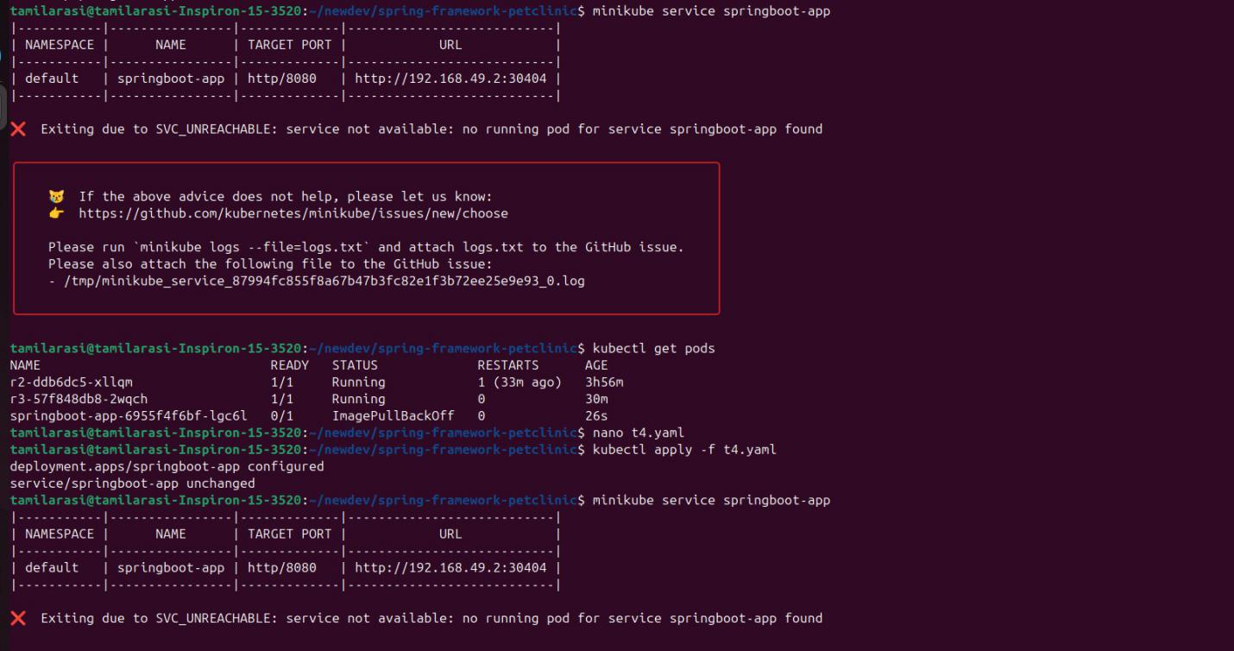

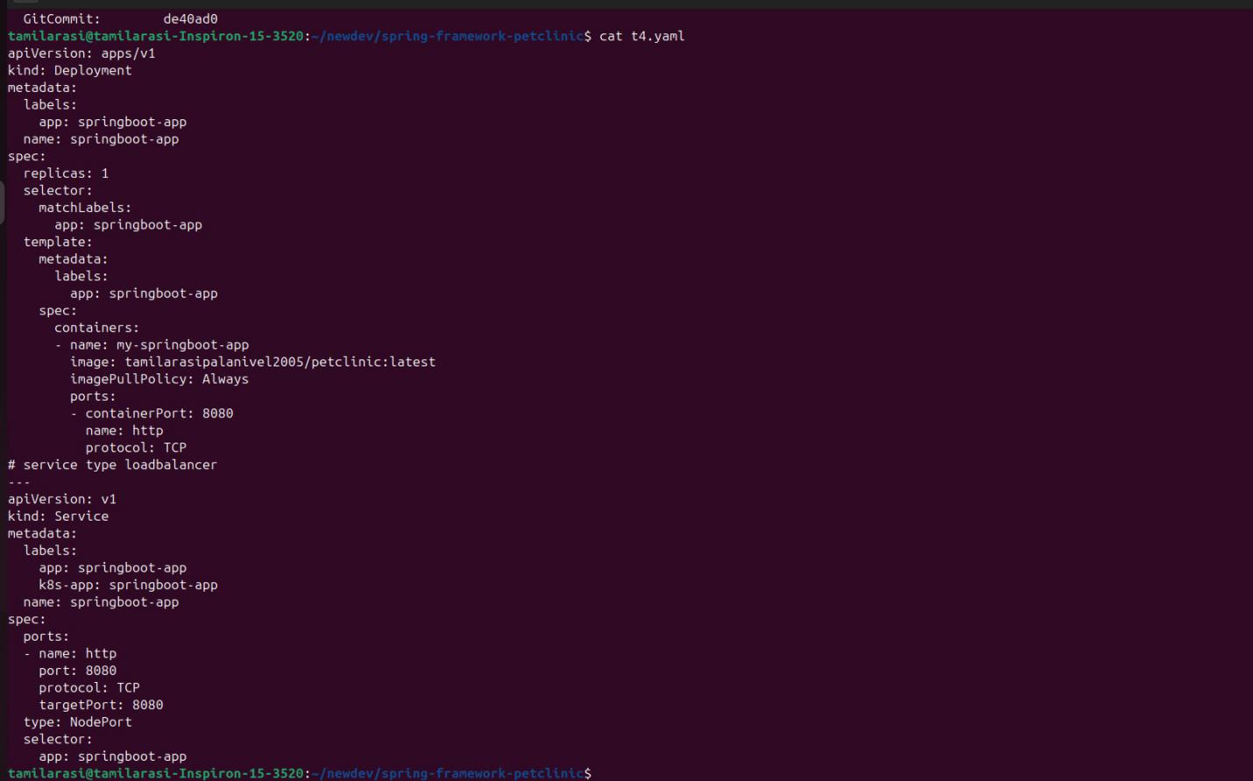

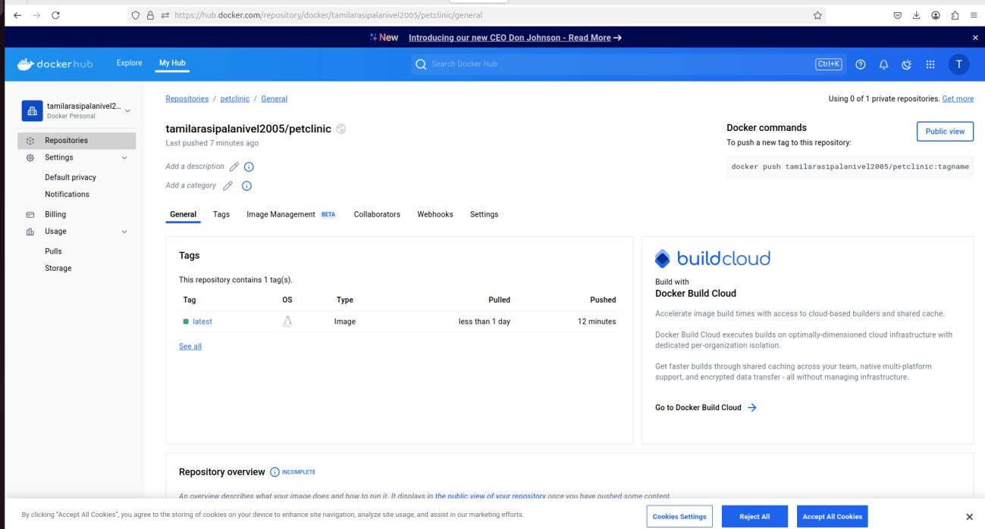**STEP 5:** Using kubernetes pull the image and host

**STEP 6 :** Verify that the pods are running using the command:

Kubectl get pods and service

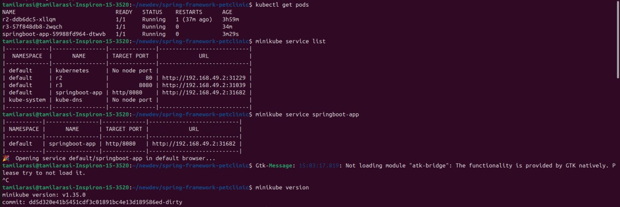

**STEP 7:** Use the obtained URL to view the output in the browse

